How to generate a Claim from an Invoice

1. Create an order. (Ex- 7909)

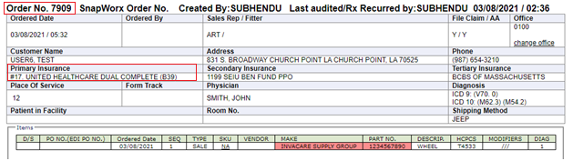

1. Note down the order no, Insurance name and order amount
2. Generate the invoice (Ex- 10491)
3. Search the associate customer (Ex-12163)
4. Click on the customer.
5. Click on Claim Filling under Claims

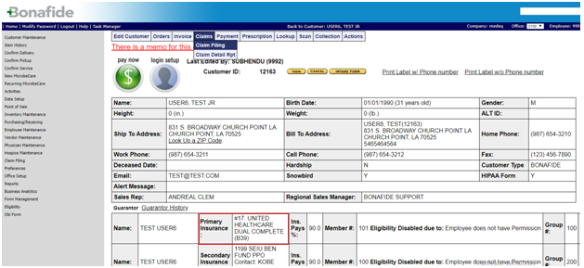

1. Check the Claim No, order no, insurance name, claim amount and invoice amount. All should be same as compare with previous .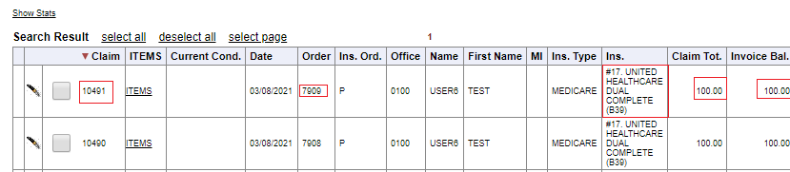
2. Check the Claim checkbox and Click on “Print (New)” under Available Actions

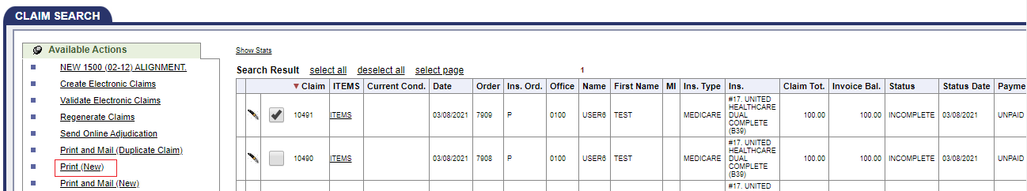

1. A claim file will be downloaded to print.

Please check the below claim file for reference.

